Web Application Architectures

Lab 5 – Next.js layout and styling

What is Next.js Layout?
Next.js is a React framework built by Vercel
It adds powerful features on top of React such as:
- File-based routing: create routes by adding files in the app/ or pages/ directory.
- Server-side rendering (SSR) & static site generation (SSG): pre-render content for speed and SEO.
- API routes: build backend endpoints alongside your frontend.
- Full-stack React: use both server and client components in the same project.
- Performance optimizations: image optimization, font optimization, caching, and bundling out of the box.
Source: https://nextjs.org/learn/dashboard-app/getting-started

Getting Started:
Next.js recommends using pnpm as the package manager, as it's faster and more efficient than npm or yarn. If you don't have pnpm installed, you can install it globally by running:
In the Lab_4 project in VS Code, open a terminal window and run:  npm install -g pnpm | 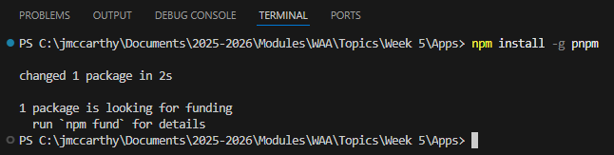

Source: https://nextjs.org/learn/dashboard-app/getting-started

Create a new Next App
To create a Next.js app, in the lab_4 terminal in VS Code, run the following command:
npx create-next-app@latest lab_5_app --use-pnpm
This command uses create-next-app, a Command Line Interface (CLI) tool that sets up a Next.js application for you.
When prompted select the following options:
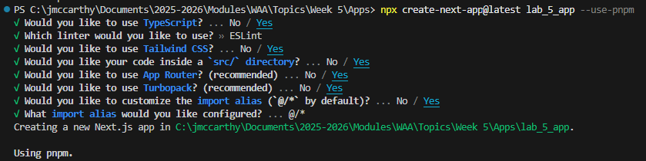
Source: https://nextjs.org/learn/dashboard-app/getting-started

Folder structure:
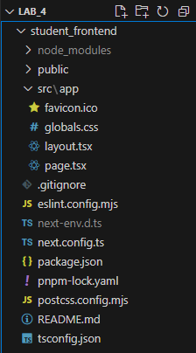 | /app: Will contain all the routes, components, and logic for your application, this is where you'll be mostly working from.  /app/lib: Contains functions used in your application, such as reusable utility functions and data fetching functions.  /app/ui: Contains all the UI components for your application, such as cards, tables, and forms.  /public: Contains all the static assets for your application, such as images.  Config Files: You'll also notice config files such as next.config.ts at the root of your application. Most of these files are created and pre-configured when you start a new project using create-next-app. You will not need to modify them in this course.

Install dependencies:
Cd into the new next app:  cd lab_5_app  pnpm add lucide-react | 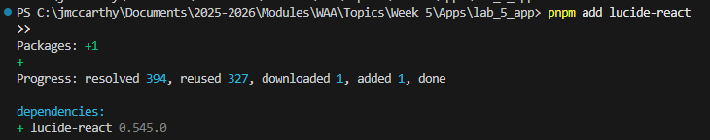

Run the server:
Run:  pnpm dev | 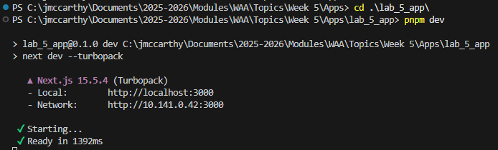

Open http://localhost:3000 on your browser. Your home page should look as follows:
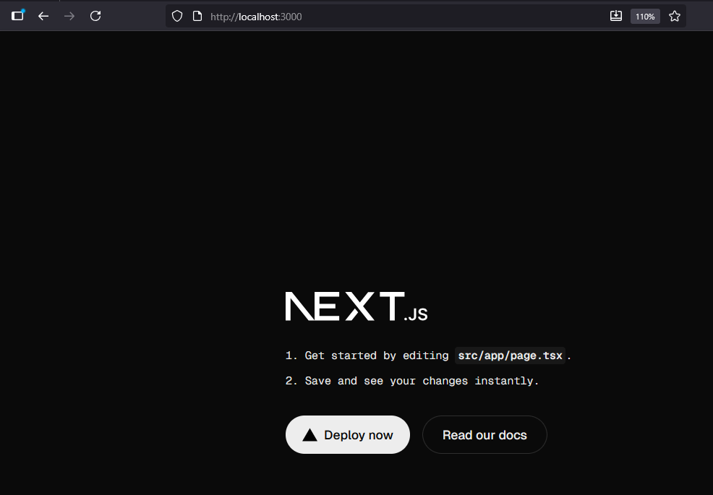

Layout Structure in Next.js 15
With the App Router, the layout system uses:
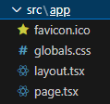
The layout.tsx file defines the root layout for all routes.
Update our src/app/layout.tsx to look as follows
import type { Metadata } from "next";  import "./globals.css";  export const metadata: Metadata = {  title: "Lab 5 App",  description: "Layout and Styling",  };  export default function RootLayout({  children,  }: Readonly<{  children: React.ReactNode;  }>) {  return (  <html lang="en">  <body>  {children}  </body>  </html>  );  } | 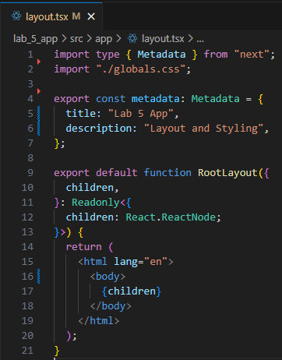

This code defines the root layout for a Next.js application using the App Router. It begins by importing the Metadata type from Next.js and a global CSS file (globals.css) to apply consistent styling across the app. The metadata object sets the page's title and description, which Next.js uses to populate the <head> section for SEO and browser tab labeling. The RootLayout component is a special layout component that wraps all pages in the app. It receives children—the content of each individual page—and renders it inside a basic HTML structure with <html lang="en"> and <body>. This layout ensures that every page in the app shares the same HTML scaffold and global styles, making it a foundational part of the app's structure.

Landing Page in Next.js 15
In Next.js the landing page is located at src/app/page.tsx
Update the page.tsx file to look as follows:
"use client";  import { useState } from "react";  import { Menu, X } from "lucide-react";  import Image from "next/image";  import Link from "next/link";  export default function HomePage() {  const navLinks = [  { name: "Home", href: "#" },  { name: "About", href: "#about" },  { name: "Projects", href: "#projects" },  { name: "Contact", href: "#contact" },  ];  return (  <div className="bg-gray-50 text-gray-900 flex flex-col min-h-screen">  {/* ===== Header + Navigation ===== */}  <header className="bg-white/80 backdrop-blur-md shadow-sm sticky top-0 z-50">  <div className="max-w-7xl mx-auto px-6 py-4 flex items-center justify-between">  <h1 className="text-2xl font-bold text-blue-600">Sarah Connor</h1>  {/* Navigation Links */}  <ul  className="absolute md:static bg-white md:bg-transparent left-0 w-full md:w-auto top-16 md:top-auto border-t md:border-none md:flex md:space-x-8 transition-all duration-300 ease-in"  >  {navLinks.map((link) => (  <li key={link.name}>  <Link  href={link.href}  className="block px-6 py-3 text-gray-700 hover:text-blue-600 font-medium transition"  >  {link.name}  </Link>  </li>  ))}  </ul>  </div>  </header>  {/* ===== Hero Section ===== */}  <section  id="home"  className="flex flex-col items-center justify-center text-center py-28 px-6 bg-gradient-to-b from-blue-50 to-white"  >  <Image  src="/profile.jpg"  alt="Profile"  width={128}  height={128}  className="rounded-full shadow-lg mb-6 border-4 border-white"  />  <h1 className="text-5xl md:text-6xl font-extrabold mb-4">  Hi, I’m <span className="text-blue-600">Sarah Connor</span>  </h1>  <p className="text-lg md:text-xl text-gray-600 max-w-2xl mb-8">  A Frontend Developer passionate about building elegant and performant  web experiences with Next.js, Tailwind CSS, and TypeScript.  </p>  <div className="flex gap-4">  <a  href="#projects"  className="bg-blue-600 text-white px-6 py-3 rounded-full font-semibold hover:bg-blue-700 transition"  >  View My Work  </a>  <a  href="#contact"  className="border border-blue-600 text-blue-600 px-6 py-3 rounded-full font-semibold hover:bg-blue-50 transition"  >  Contact Me  </a>  </div>  </section>  {/* ===== About Section ===== */}  <section id="about" className="py-20 px-6 bg-white">  <div className="max-w-5xl mx-auto text-center">  <h2 className="text-3xl md:text-4xl font-bold mb-6 text-gray-800">  About Me  </h2>  <p className="text-gray-600 max-w-3xl mx-auto text-lg leading-relaxed">  I’m a developer with a passion for creating digital experiences that  blend design and functionality. I specialize in building responsive,  user-centered web applications using modern technologies like  <span className="font-medium text-blue-600">  {" "}  React, Next.js, and Tailwind CSS.  </span>{" "}  I enjoy collaborating with teams to bring ideas to life and  constantly explore new tools to improve my workflow.  </p>  </div>  </section>  {/* ===== Projects Section ===== */}  <section id="projects" className="py-20 px-6 bg-gray-100">  <div className="max-w-6xl mx-auto text-center">  <h2 className="text-3xl md:text-4xl font-bold mb-12 text-gray-800">  Projects  </h2>  <div className="grid sm:grid-cols-2 lg:grid-cols-3 gap-8">  {/* Project Card */}  {[  {  title: "Portfolio Website",  description:  "A sleek, responsive portfolio built with Next.js and Tailwind CSS.",  image: "/project1.jpg",  },  {  title: "E-Commerce Store",  description:  "A full-stack store with Next.js, Stripe, and MongoDB integration.",  image: "/project2.jpg",  },  {  title: "SaaS Dashboard",  description:  "An interactive admin dashboard with charts and dark mode support.",  image: "/project3.jpg",  },  ].map((project, index) => (  <div  key={index}  className="bg-white rounded-xl shadow-md hover:shadow-xl transition overflow-hidden"  >  <Image  src={project.image}  alt={project.title}  width={400}  height={250}  className="w-full h-48 object-cover"  />  <div className="p-6 text-left">  <h3 className="text-xl font-semibold mb-2 text-gray-800">  {project.title}  </h3>  <p className="text-gray-600 text-sm mb-4">  {project.description}  </p>  <a  href="#"  className="text-blue-600 font-medium hover:underline"  >  View Project →  </a>  </div>  </div>  ))}  </div>  </div>  </section>  {/* ===== Contact Section ===== */}  <section id="contact" className="py-20 px-6 bg-white">  <div className="max-w-4xl mx-auto text-center">  <h2 className="text-3xl md:text-4xl font-bold mb-6 text-gray-800">  Get In Touch  </h2>  <p className="text-gray-600 mb-8">  Whether you want to collaborate or just say hello, feel free to drop  me a message.  </p>  <a  href="#"  className="inline-block bg-blue-600 text-white px-8 py-3 rounded-full font-semibold hover:bg-blue-700 transition"  >  Say Hello  </a>  </div>  </section>  {/* ===== Footer ===== */}  <footer className="bg-gray-900 text-gray-300 py-6">  <div className="max-w-7xl mx-auto text-center text-sm">  © Sarah C. {new Date().getFullYear()}  </div>  </footer>  </div>  );  } | 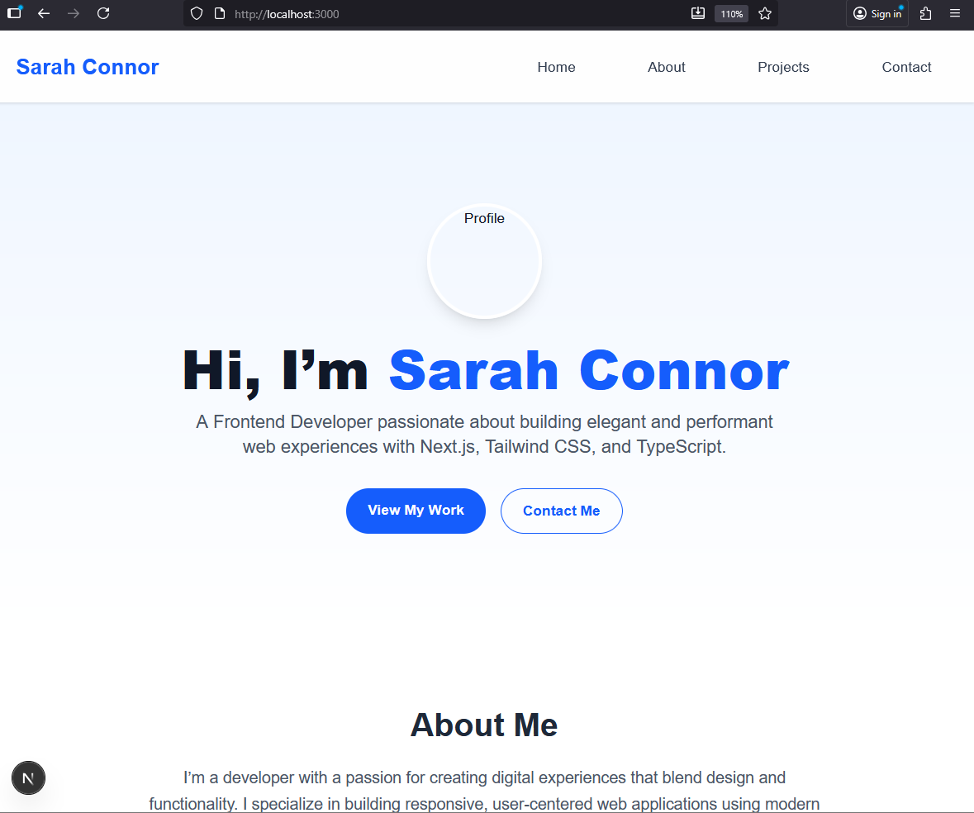  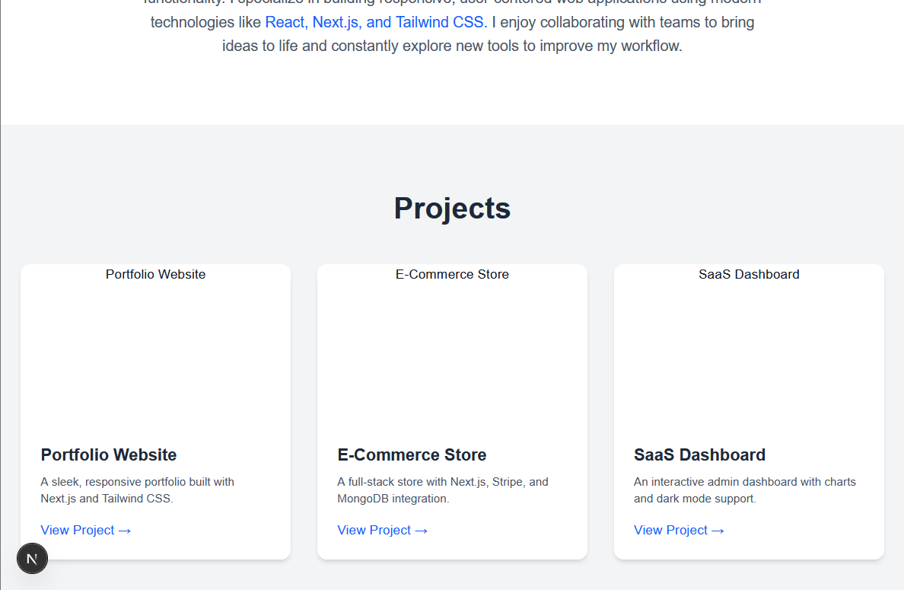  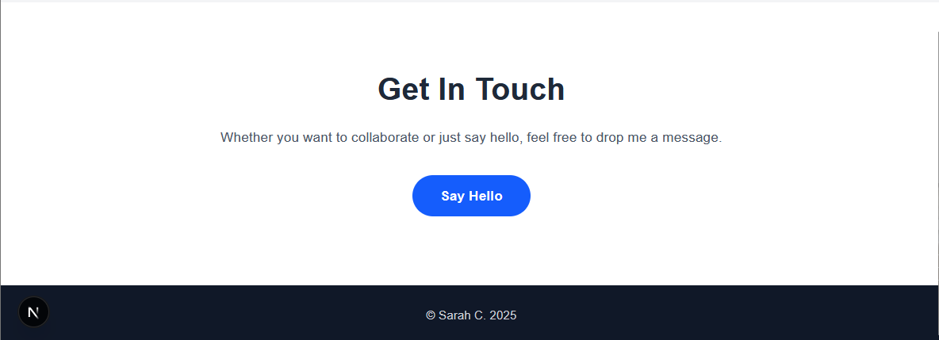

This file defines the main homepage of your Next.js application using the App Router. It’s a client-side rendered component (indicated by "use client"), meaning it runs entirely in the browser and supports interactivity like state management and dynamic UI updates.

What our landing page offers to the app
1. Client-Side Interactivity
The "use client" directive enables React hooks like useState, which are used here to potentially manage UI state (though not actively used in this snippet).
This allows for future enhancements like toggling mobile menus or animations.

2. Responsive Navigation
Uses Tailwind CSS for styling.
Navigation links (Home, About, Projects, Contact) are rendered dynamically from an array.
Responsive design is supported via utility classes (md:flex, sticky, backdrop-blur-md).
3. Hero Section
Introduces the developer (Sarah Connor) with a profile image and a short bio.
Includes CTA buttons: “View My Work” and “Contact Me”.
4. About Section
Describes the developer’s background, skills, and passion.
Emphasizes technologies like React, Next.js, and Tailwind CSS.
5. Projects Section
Displays a grid of project cards with images, titles, and descriptions.
Projects are hardcoded but could easily be made dynamic via props or data fetching.
6. Contact Section
Encourages visitors to get in touch.
Includes a styled button for initiating contact (could be linked to a form or email).
7. Footer
Simple footer with copyright.

Create separate Components
Now that we have a completed landing page we will try break this up into different components. For our project we will create new components for:
- Header
- Hero
- About
- Projects
- Contact
- Footer
Splitting your Next.js page into reusable components is not just a matter of tidiness — it directly improves scalability, maintainability, performance, and developer experience.
We will create the new components in the next step. The following description offers some details on why this is beneficial to the project.

Reusability
Components can be reused across pages.
For example:
- The same <Header /> and <Footer /> appear on every page (Home, About, Contact, etc.)
- A <ProjectCard /> can be used inside multiple pages or even a blog post preview.
- This eliminates duplicate code and makes updates consistent.
- Eg. Change your logo in Header.tsx once and it automatically updates everywhere.

With components:
- Each piece is self-contained.
- You can update, debug, or replace just one section.
- Easier to test or review in isolation.

When each logical section is a separate component:
- Your IDE can auto-complete props and show type hints.
- You can unit test specific UI parts.
- You can lazy-load certain components (e.g., animations, 3D graphics) for performance.

What is a Component?
React Components
- With React components are the building blocks for the User Interface.
- The offer self-contained and reusable components that encapsulate specific behavior and functionality.
- A React application usually used a variety of different components.
- A React component can be a:
  - JS Class
  - Function
- The function is now the preferred way to create a component

React Components are the primary building blocks of the app.
It uses React Elements and JSX to design the UI.
The React component can be a JS Class (extends the React component class) or a pure JavaScript function.
A React Component can have:
- Properties (Props)
- State management
- Life Cycle
- Event handlers
A component can cater for simple or complex logic.

Functional Components
- JS function that returns React elements.
- This basically dictates what will display on the screen.
- Appear to be stateless and they don’t manage their own internal state.
- Will receive data through props (properties).
- Naming convention will follow Pascal Casing.

Demo of a simple component
This is what a component looks like.
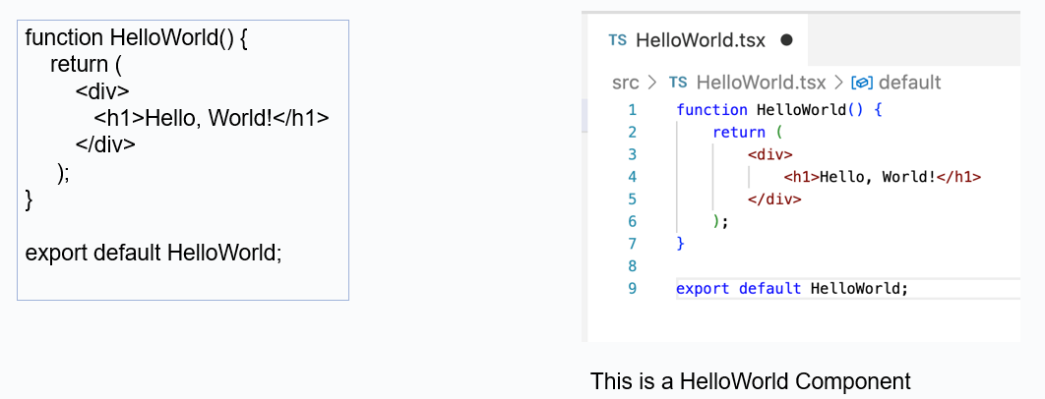

Components Summary
- Components are like building blocks, making them reusable.
- Components let you organize UI into small, focused pieces.
- Each component handles its own markup, styling, and logic.
- Each component manages its own state (data it needs to work).
- Components can be nested and combined to build complex UIs from simple parts.

Create our new Header component
In the src directory create a new directory named components.  In the components directory create a new component named Header.tsx | 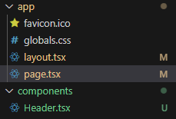

Add the following basic structure to our Header.tsx
"use client";  import { useState } from "react";  import { Menu, X } from "lucide-react";  import Link from "next/link";  export default function Header() {  return (  <p>This is our header</p>  );  } | 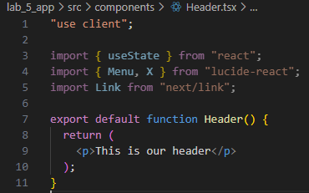

Test our new component (Use it inside page.tsx):
Open src/app/page.tsx and add the following above the <header> section
To call the component add the following :  // Top of the page  import Header from "@/components/Header";  // Where on the page we want to call the component  <Header /> | 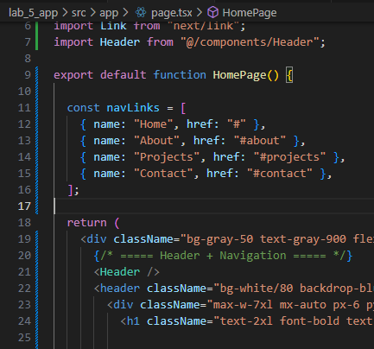

Save all files and test the app:
Our simple header should produce:
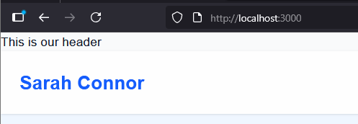

Now we can move the content of the header to our new <Header / > component:
Cut the html header content form the page and add this to our Header.tsx file:
"use client";  import Link from "next/link";  export default function Header() {  const navLinks = [  { name: "Home", href: "#" },  { name: "About", href: "#about" },  { name: "Projects", href: "#projects" },  { name: "Contact", href: "#contact" },  ];  return (  <header className="bg-white/80 backdrop-blur-md shadow-sm sticky top-0 z-50">  <div className="max-w-7xl mx-auto px-6 py-4 flex items-center justify-between">  <h1 className="text-2xl font-bold text-blue-600">Sarah Connor</h1>  {/* Navigation Links */}  <ul  className="absolute md:static bg-white md:bg-transparent left-0 w-full md:w-auto top-16 md:top-auto border-t md:border-none md:flex md:space-x-8 transition-all duration-300 ease-in"  >  {navLinks.map((link) => (  <li key={link.name}>  <Link  href={link.href}  className="block px-6 py-3 text-gray-700 hover:text-blue-600 font-medium transition"  >  {link.name}  </Link>  </li>  ))}  </ul>  </div>  </header>  );  } | 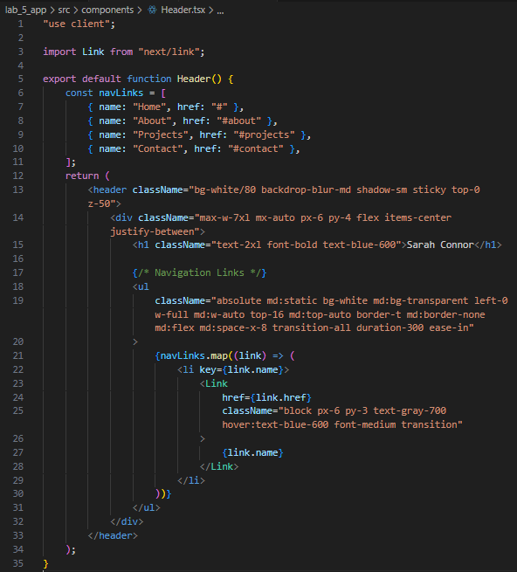

The page should now look as follows:
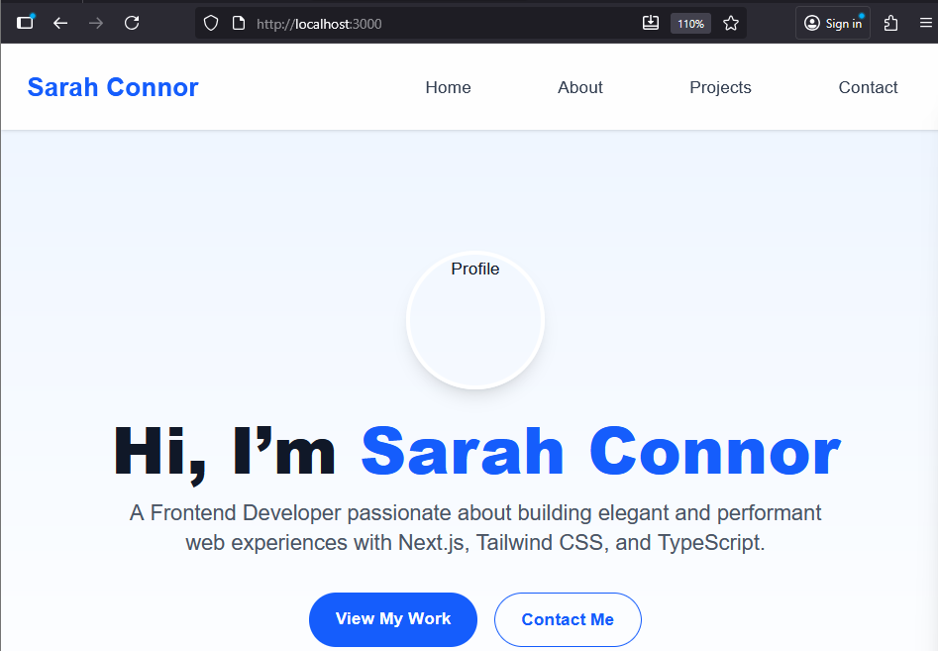

Create our new Footer component
Create a new component named Footer.tsx

"use client";  export default function Header() {  return (  <footer className="bg-gray-900 text-gray-300 py-6">  <div className="max-w-7xl mx-auto text-center text-sm">  © Sarah C. {new Date().getFullYear()}  </div>  </footer>  );  } | 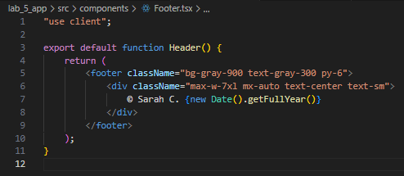

Update page.tsx to look as follows:
First add the import for the Footer component:
import Footer from "@/components/Footer";

Second remove the html footer markup and add the component: <Footer />
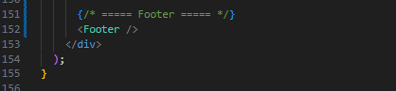

Test the page:
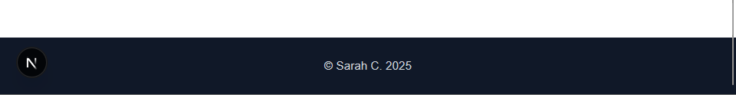

Create components for Hero, About, Projects and Contact
Follow the same process as the Header and Footer to create new components for Hero, About, Projects and Contact

The project should eventually look as follows:
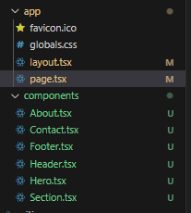 | 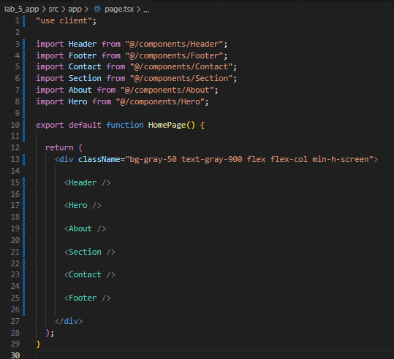

Todo:
Try add a placeholder picture for Sarah.

Passing data to and from Components

What are props?
Props let you pass data from a parent component (like page.tsx) to a child component (like Header, Hero, Projects, etc.).
Think of them like function parameters — components are just functions that return UI.

Create a new example
We will create an example to retrieve data from a free API and use this data in our Projects component.

We will use JSONPlaceholder
It provides placeholder data like posts, which we can treat as projects:
https://jsonplaceholder.typicode.com/photos?_limit=6
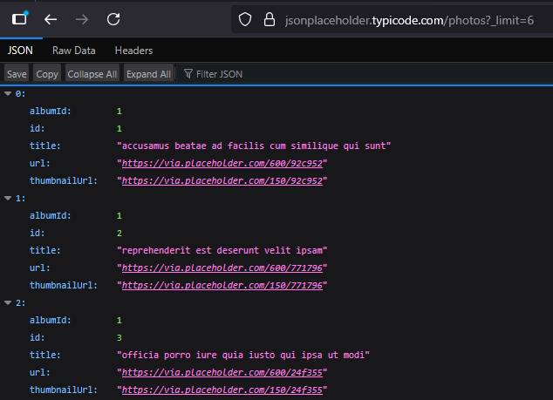

Update the Sections component to look as follows:
"use client";  import { useEffect, useState } from "react";  type Project = {  id: number;  title: string;  thumbnailUrl: string;  url: string;  };  export default function Projects() {  const [projects, setProjects] = useState<Project[]>([]);  const [loading, setLoading] = useState(true);  useEffect(() => {  fetch("https://jsonplaceholder.typicode.com/photos?_limit=6")  .then((res) => res.json())  .then((data) => {  setProjects(data);  setLoading(false);  })  .catch((err) => {  console.error(err);  setLoading(false);  });  }, []);  if (loading) {  return (  <section className="py-20 px-6 bg-gray-100 text-center">  <p className="text-gray-700">Loading projects...</p>  </section>  );  }  return (  <section id="projects" className="py-20 px-6 bg-gray-100">  <div className="max-w-6xl mx-auto text-center">  <h2 className="text-3xl md:text-4xl font-bold mb-12 text-gray-800">  Projects  </h2>  <div className="grid sm:grid-cols-2 lg:grid-cols-3 gap-8">  {projects.map((project) => (  <div  key={project.id}  className="bg-white rounded-xl shadow-md hover:shadow-xl transition overflow-hidden"  >  <img  src={project.thumbnailUrl}  alt={project.title}  className="w-full h-48 object-cover"  />  <div className="p-6 text-left">  <h3 className="text-xl font-semibold mb-2 text-gray-800">  {project.title}  </h3>  <a  href={project.url}  target="_blank"  rel="noopener noreferrer"  className="text-blue-600 font-medium hover:underline"  >  View Project →  </a>  </div>  </div>  ))}  </div>  </div>  </section>  );  } | 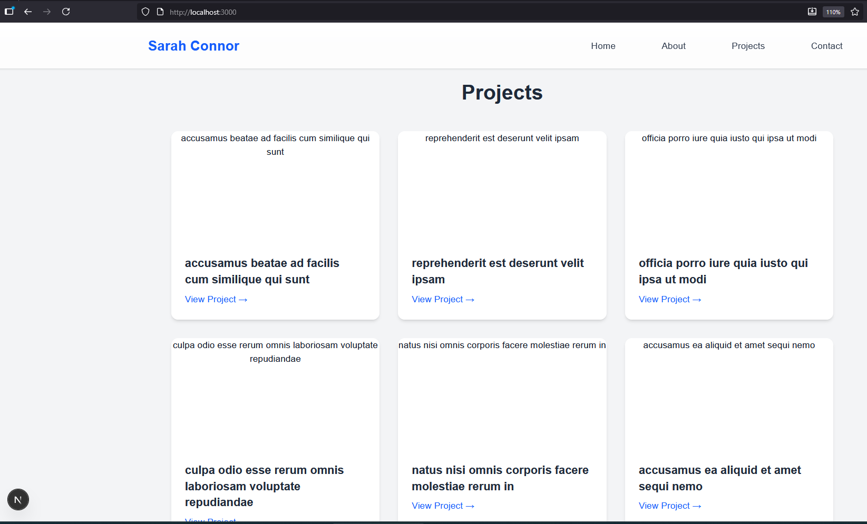

Description:
The component is marked as a client component, which means it runs in the browser rather than on the server. This is necessary because it uses React features that only work in the browser, like managing state and performing side effects.

The component keeps track of two main pieces of information:
- Projects Data – an array that will eventually store the list of projects fetched from the API.
- Loading State – a boolean that indicates whether the data is still being loaded or is ready to display.
These two pieces of state allow the component to reactively update the user interface when new data arrives or when it is still loading.

When the component first appears on the page, it automatically sends a request to a free online API that provides placeholder project information. This API returns a list of items, each with a title, an image, and a link.
Once the data arrives, the component:
- Stores the project information in its internal state
- Updates the loading state to indicate that data is ready
If an error occurs during the request, it logs the error and stops the loading state so the component doesn’t stay in a loading loop.

While the data is being fetched, the component shows a simple loading message to the user. This prevents empty content from appearing on the page and gives the user feedback that something is happening.
Once the data has loaded, the component automatically re-renders itself to show the list of projects.

For each project retrieved from the API, the component creates a visual card that includes:
- A project image
- The project title
- A link that opens the project in a new tab

Styling Net.js with Tailwind
Tailwind CSS is a utility-first CSS framework, meaning it provides small, reusable classes to control spacing, typography, color, layout, and more. Instead of writing custom CSS for each element, you compose styles directly in your HTML (or JSX, Vue, etc.) using pre-defined classes.

Eg:
<button class="bg-blue-500 text-white px-4 py-2 rounded hover:bg-blue-600">
Click Me
</button>
Where:
bg-blue-500 | background color
text-white | text color
px-4 py-2 | padding
rounded | border radius
hover:bg-blue-600 | hover effect

Advantages
- No CSS bloat: Only the classes you use are included in production.
- Fast prototyping: You can visually build layouts without writing CSS.
- Highly customizable: Change theme colors, spacing, breakpoints in tailwind.config.js.
- Consistency: Using predefined spacing, colors, and typography keeps design consistent.

ShadCN - https://ui.shadcn.com/
ShadCN is a popular developer and designer in the React and frontend ecosystem, best known for creating high-quality UI component libraries and design systems, particularly those built with Tailwind CSS. One of the most notable contributions is the ShadCN/ui library, which provides prebuilt, accessible, and customizable React components that follow modern design practices.

ShadCN/ui offers:
- A collection of React components (buttons, modals, forms, tables, etc.).
- Built with Tailwind CSS for easy customization.
- Focuses on accessibility and clean, modern design.
- Works well in Next.js, React, and other React-based frameworks.

We will create a new Next.js project to demo ShadCN

Create a new project:
npx create-next-app@latest my-shadcn-app  cd my-shadcn-app  npm install next-themes | 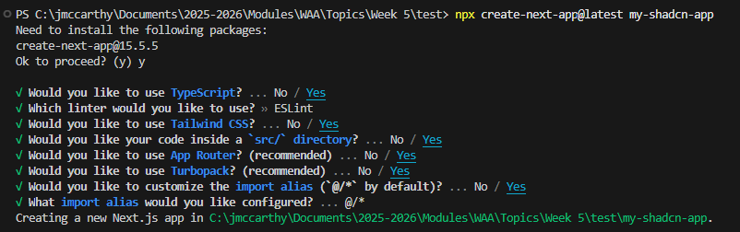

We are choosing Yes for Tailwind.

Run the Project:
npm run dev | 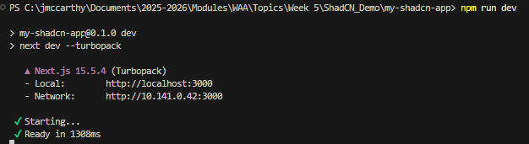

Install ShadCN:
npx shadcn@latest init | 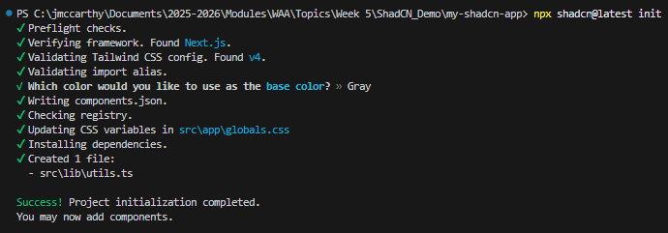

Add components:
npx shadcn@latest add button input card | 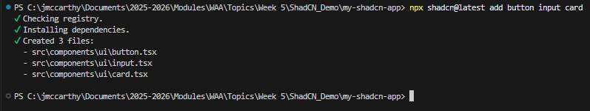

button / input / card are component names
These are the specific UI components you want to generate.
For each component:
- The CLI creates a React component file in your project (usually under components/ui/).
- Adds Tailwind CSS classes and a default structure.
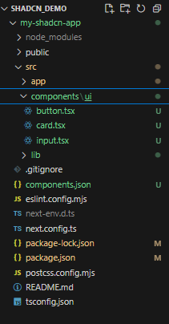 | These components are now available for use in the project.

Setup the Project
Update app/layout.tsx to look as follows:
"use client";  import { ThemeProvider } from "next-themes";  import "./globals.css";  export default function RootLayout({ children }: { children: React.ReactNode }) {  return (  <html lang="en" suppressHydrationWarning>  <body>  <ThemeProvider attribute="class" defaultTheme="light" enableSystem={false}>  {children}  </ThemeProvider>  </body>  </html>  );  } | 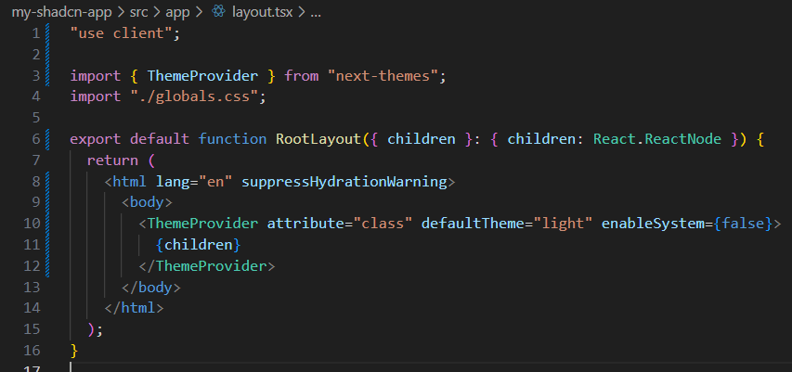

We wlll use next-themes to toggle the dark class on <html> automatically.
attribute="class" tells it to toggle the .dark class.
suppressHydrationWarning avoids mismatch errors when hydrating the theme.

Update the landing page (app/page.tsx)
Update app/page.tsx
"use client";  import { useState, useEffect } from "react";  import { useTheme } from "next-themes";  import { Button } from "@/components/ui/button";  import { Input } from "@/components/ui/input";  import { Card } from "@/components/ui/card";  export default function Page() {  const { theme, setTheme } = useTheme();  const [mounted, setMounted] = useState(false);  // Ensures this component only renders theme-dependent UI after hydration  useEffect(() => {  setMounted(true);  }, []);  // Avoid hydration mismatch by not rendering theme UI until mounted  if (!mounted) {  return (  <div className="min-h-screen flex items-center justify-center bg-background text-foreground">  <p>Loading...</p>  </div>  );  }  return (  <div className="min-h-screen flex flex-col">  {/* Navbar */}  <nav className="flex justify-between items-center px-6 py-4 border-b border-border bg-card text-card-foreground">  <h1 className="text-lg font-semibold">ShadCN Demo</h1>  <Button  variant="outline"  onClick={() => setTheme(theme === "dark" ? "light" : "dark")}  >  {theme === "dark" ? "☀️ Light" : " Dark"}  </Button>  </nav>  {/* Content */}  <main className="flex flex-1 items-center justify-center bg-background text-foreground transition-colors">  <Card className="p-8 w-full max-w-sm space-y-4">  <h2 className="text-xl font-semibold text-center">Welcome!</h2>  <Input placeholder="Enter your name" />  <Button className="w-full">Submit</Button>  </Card>  </main>  </div>  );  } | 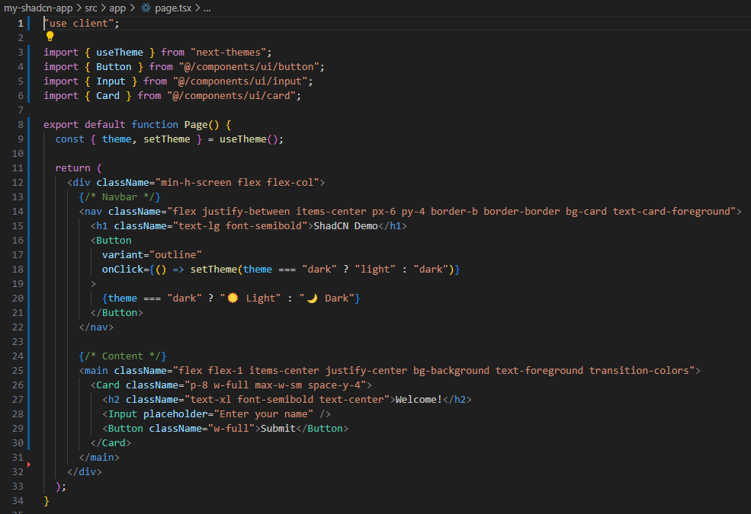

This page component is a client-side React component that uses the ShadCN UI library and the next-themes package. It first imports the theme hook and UI components such as a button, input, and card. Inside the component, it retrieves the current theme and a function to toggle between light and dark modes. The layout consists of a full-height flex container with a top navigation bar and a centered content area. The navbar displays a title on the left and a toggle button on the right that switches between light and dark themes. Below it, the main section centers a card that contains a welcoming heading, an input field for user text, and a full-width submit button. The entire design adapts its colors automatically based on the active theme, providing a clean and responsive dark/light mode experience.

Run the project:
Npm run dev
Got to localhost:3000
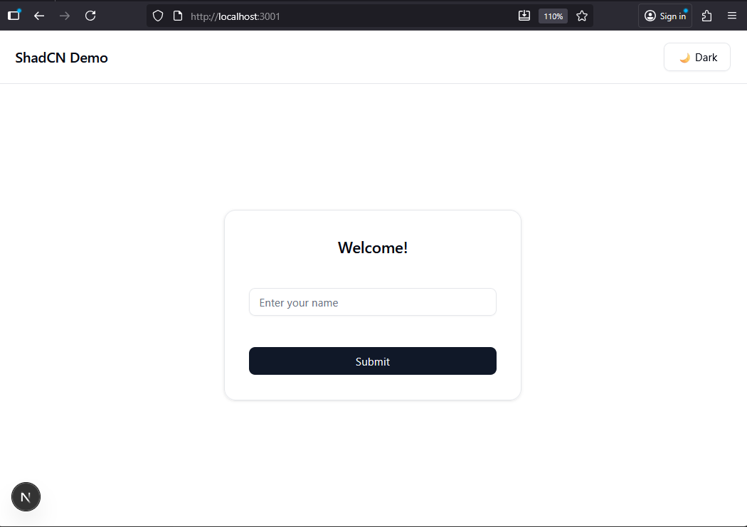

Create a new Form Page using ShadCN components

Requirements:
The page would display a centered registration card styled with ShadCN’s design system. Inside the card, there would be:
A heading such as “Create an Account.”
Three input fields for name, email, and password.
A Submit button.
When the user clicks Submit, the form simulates saving the information (you could later connect this to an API). Immediately afterward, a toast notification appears — a small message near the bottom or top corner saying “Registration successful!” with a pleasant animation.

Setup:
Add the Sonner Component. We will use this to access Toaster (there is a the toast component hasn’t yet been published for the new “New York v4” registry (which is the default for Tailwind v4 / Next 15 projects))
npm install sonner

Add this to app/layout.tsx
import { Toaster } from "sonner";  <Toaster richColors closeButton position="top-right" /> | 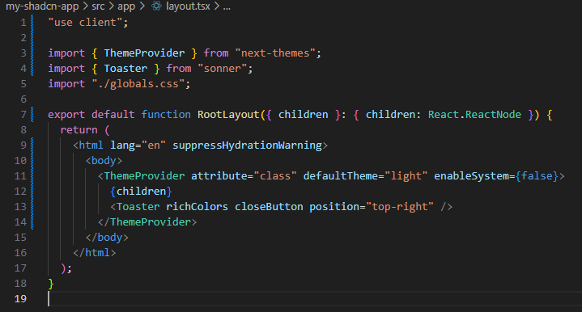

Setup the form:
Add the Field Component
Run:
npx shadcn@latest add field
This adds components for:
- Field
- Label
- Description
- Message components
- and updates your styles to support them.

We need to create a new page for our register form.
In the app directory create a new directory named register.
In the register directory create page.tsx
Add the following to page.tsx:
"use client";  import { useState } from "react";  import { toast } from "sonner";  import { Card } from "@/components/ui/card";  import { Input } from "@/components/ui/input";  import { Button } from "@/components/ui/button";  import { Label } from "@/components/ui/label";  export default function RegisterPage() {  const [form, setForm] = useState({  name: "",  email: "",  password: "",  });  const [errors, setErrors] = useState({  name: "",  email: "",  password: "",  });  const handleChange = (e: React.ChangeEvent<HTMLInputElement>) => {  setForm({ ...form, [e.target.name]: e.target.value });  setErrors({ ...errors, [e.target.name]: "" }); // Clear error on change  };  const validateForm = () => {  let valid = true;  const newErrors = { name: "", email: "", password: "" };  if (!form.name.trim()) {  newErrors.name = "Name is required.";  valid = false;  }  if (!form.email.trim()) {  newErrors.email = "Email is required.";  valid = false;  } else if (!/\S+@\S+\.\S+/.test(form.email)) {  newErrors.email = "Please enter a valid email address.";  valid = false;  }  if (!form.password.trim()) {  newErrors.password = "Password is required.";  valid = false;  } else if (form.password.length < 8) {  newErrors.password = "Password must be at least 8 characters.";  valid = false;  }  setErrors(newErrors);  return valid;  };  const handleSubmit = (e: React.FormEvent) => {  e.preventDefault();  if (!validateForm()) return;  // Trigger success toast  toast.success("Registration successful!", {  description: `Welcome, ${form.name}! 🎉`,  });  // Clear form  setForm({ name: "", email: "", password: "" });  };  return (  <main className="flex min-h-screen items-center justify-center bg-background text-foreground">  <Card className="p-8 w-full max-w-sm space-y-6 shadow-lg">  <h2 className="text-2xl font-semibold text-center">Create an Account</h2>  <form onSubmit={handleSubmit} className="space-y-4">  {/* Name Field */}  <div>  <Label htmlFor="name">Full Name</Label>  <Input  id="name"  name="name"  placeholder="John Doe"  value={form.name}  onChange={handleChange}  />  <p className="text-sm text-muted">Enter your full name as it appears on your ID.</p>  {errors.name && <p className="text-red-500 text-sm">{errors.name}</p>}  </div>  {/* Email Field */}  <div>  <Label htmlFor="email">Email Address</Label>  <Input  id="email"  name="email"  type="email"  placeholder="you@example.com"  value={form.email}  onChange={handleChange}  />  <p className="text-sm text-muted">We’ll send a confirmation email here.</p>  {errors.email && <p className="text-red-500 text-sm">{errors.email}</p>}  </div>  {/* Password Field */}  <div>  <Label htmlFor="password">Password</Label>  <Input  id="password"  name="password"  type="password"  placeholder="••••••••"  value={form.password}  onChange={handleChange}  />  <p className="text-sm text-muted">At least 8 characters required.</p>  {errors.password && <p className="text-red-500 text-sm">{errors.password}</p>}  </div>  {/* Submit Button */}  <Button type="submit" className="w-full">  Register  </Button>  </form>  </Card>  </main>  );  } | 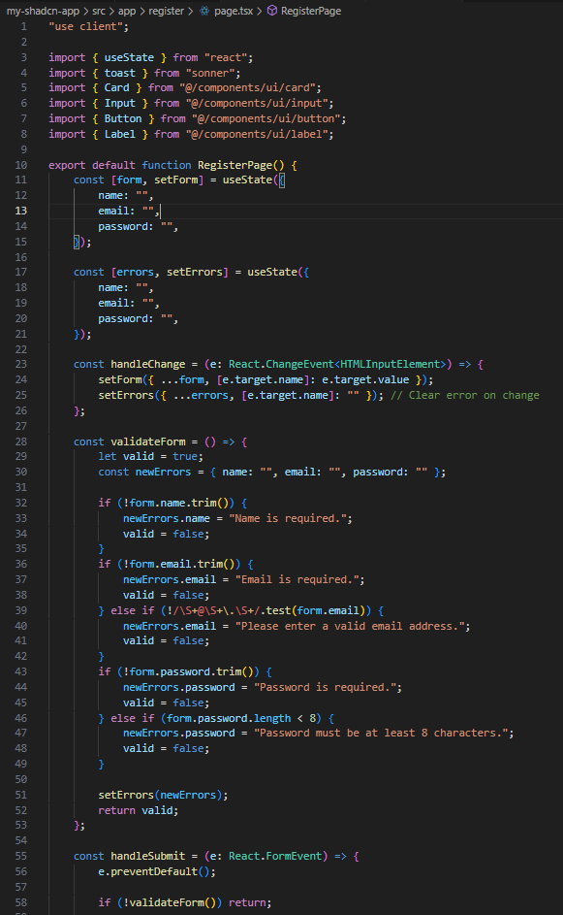  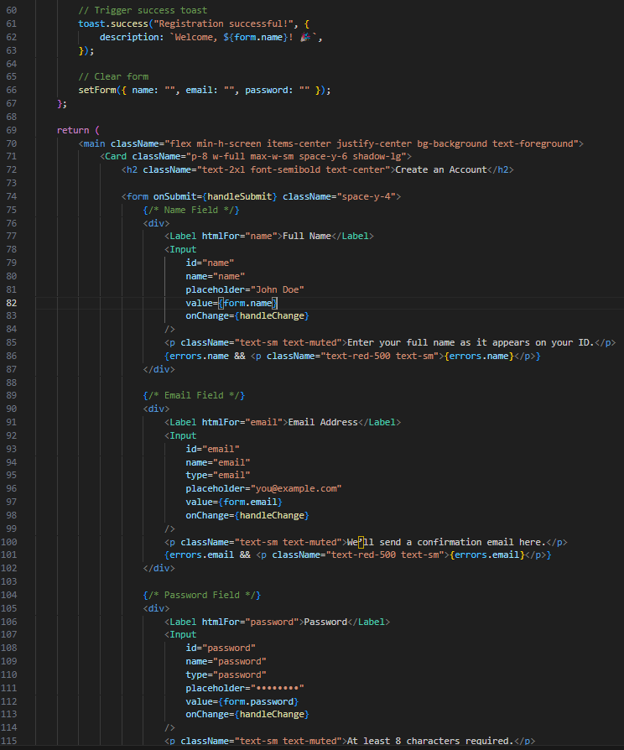  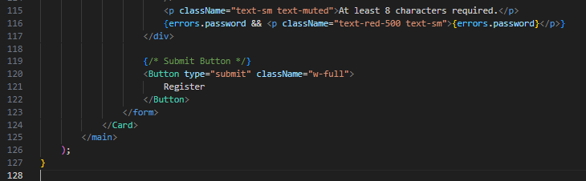

This client-side React component defines a registration page built with ShadCN UI components and basic state management. It imports useState for handling form data and validation errors, toast from Sonner for success notifications, and ShadCN components for layout and styling such as Card, Input, Button, and Label.
The component maintains two pieces of state: one for the form’s values (name, email, and password) and another for validation error messages. As users type into the form fields, their input updates the form state and clears any related error messages. Before submission, a validation function checks whether all fields are filled in, ensures that the email follows a valid format, and enforces a minimum password length of eight characters. If any field fails validation, corresponding error messages are displayed under the input fields in red text.
When the form passes validation, a success toast appears, welcoming the user by name, and the form resets to empty fields. The page is styled as a centered card with spacing and responsive text, automatically adapting its colors based on the current theme (light or dark). Overall, it demonstrates a clean, self-contained registration form using ShadCN’s design system and Sonner for feedback.

Run the app:
Npm run dev
Go to http://localhost:3000/register
Try register:
